Who Built Our Capitol?

Writers: Jen Hansen jhansen@owatonna.k12.mn.us
Missy Klapperich klapperich.missy@cf.k12.mn.us

Topic: People who built the Minnesota State Capitol

Purpose/ Relevance of the Lesson:
Students will learn that many people, with varied backgrounds and skills, are necessary to create a building like the Minnesota State Capitol.

Objectives:
Students will identify the countries or regions from which Capitol builders immigrated and reasons they came to Minnesota. Students will analyze photographs, pointing out construction site dangers and ways to make the workplace safer, investigate and identify the specific jobs involved in the building of the Capitol, and generate a list of items they would have placed in the Capitol’s cornerstone.

Grade Level: Middle School Grades

Time needed:
47 minutes to view the video
90 minutes (30 minutes for each activity in Lessons 2-4) Each activity in these lessons can stand alone if time is limited Additional time, 60 minutes or more, would be necessary for extended activities associated with Lesson 3 and Lesson 5 Jeopardy game.

Materials Needed/Used:
Video: Who Built Our Capitol? http://www.whobuiltourcapitol.org/
Documents/worksheets included in these lesson plans
Computer access for each student or small group of students
Download Google Map at: https://mapsengine.google.com/map/u/0/edit?mid=zGCv4eqYm26A.k6Ucle3H8Va4

SMART Notebook Jeopardy game board http://exchange.smarttech.com/details.html?id=6e979757-554e-48b3-9598-83d008b00924
Note: See access note under Lesson 5

Academic Standards Covered:

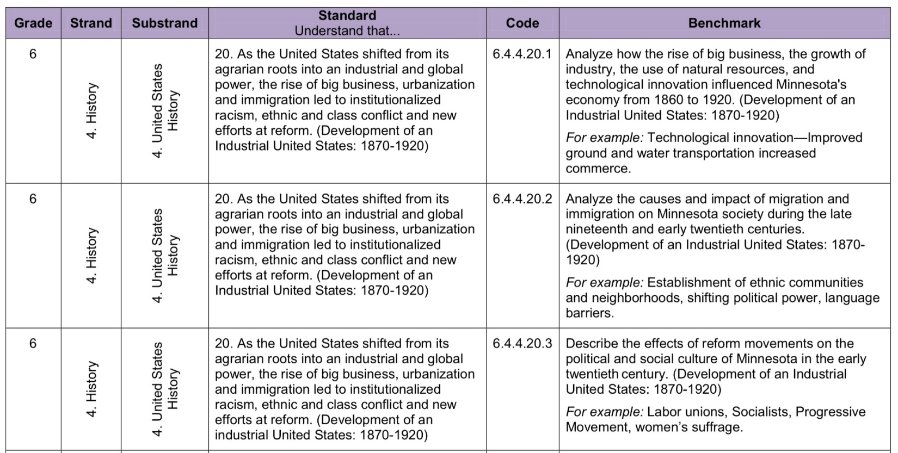

Background Knowledge: (from documentary opening narration)
On July 27, 1898, marching bands led thousands of people to the highest point in downtown St. Paul, Minnesota. Columns of veterans, stonecutters and other workers marched to the ribbon-draped speakers’ stand. Here, the new capitol was rising from the ground. Onlookers leaned over the partially finished first floor walls. Among the throng of dignitaries was Minnesota’s first territorial governor, Alexander Ramsey, to officially lay the cornerstone for the people’s house - the grandest building in the state and one of the finest statehouse buildings in the country.
The cornerstone was five feet long with a hollow core to hold a copper box. Into the box were placed more than 45 books, newspapers, photos and documents - including histories of legislators and soldiers since the founding of the state. The names of the Capitol Commissioners and architect Cass Gilbert, as well as his associates, were etched on a bronze plate. But the box contained not a single name of a worker or contractor who erected this structure. Since construction began in 1896, hundreds of workers were drawn to this spot – they dug and laid the foundation and built the lower walls. Hundreds more came to work there through the building’s completion in 1907.
For some, it would be the spark for a long, successful career and the beginning of generations in Minnesota; for others, it was one stop of many in a wandering artisan’s life; and for still others it marked the end of their lives. These people all came together to create this Minnesota icon, but they have remained nameless - until now. This is their story.
Connections:
These lessons are a great way to prepare your students for a visit to the Minnesota State Capitol. It will help students notice aspects of the Capitol tour they most likely wouldn’t otherwise observe. Students will gain an added appreciation for the artisanship and craftsmanship of the individuals who dedicated their time and talents to this magnificent landmark. In addition, students will make connections between what they have learned about early Minnesota immigrants and the skills specific individuals brought with them. Chances are good that if they look back in their own family history, they will find ancestors who held some of the same occupations as those discussed here.

Lesson Procedure:
It will be most beneficial for students to have completed reading Chapter 7: “Minnesota Newcomers” from Northern Lights pages 124-139 on early immigration to Minnesota or use the PowerPoint “Who Chose Minnesota” to introduce immigration to Minnesota along with the push and pull reasons why immigrants left their homeland. (See attached “Who Chose Minnesota” PowerPoint.)
These lessons also touch on later sections of Northern Lights, including Chapter 8: the Civil War (especially the Missionary Ridge painting in the Governor’s Capitol Reception Room); Chapter 11: Flour, Lumber and Iron (industrialization and unions); Chapter 12: Bigger, Taller, Faster (urbanization and social classes).

Lesson 1
Watch the video, Who Built Our Capitol? http://www.whobuiltourcapitol.org/ and complete the video guide to accompany it. (See attachment to Lesson 1.)

Lesson 2
Students will work with small cooperative groups (2-3) to research a worker involved in the construction of the Minnesota State Capitol building. Students will utilize the website “Who Built Our Capitol” at http://www.whobuiltourcapitol.org/ to find the information and resources for the lessons. Using the website, students should click on the “Individual Stories” tab to locate their assigned worker (either assigned to them by their teacher using the attached spreadsheet or chosen by them) and gather the information needed to complete their worker profile guide (See Lesson 2 attachment).
Students should then access the Google map at https://mapsengine.google.com/map/edit?mid=zGCv4eqYm26A.k6Ucle3H8Va4 to get a visual sense of where their worker immigrated from, as well as where their worker lived in St. Paul. By either clicking on one of the markers that shows where a worker lived or typing the worker’s name in the search box, much of the information requested in the exercise sheet is displayed.
NOTE: There is more information available for some workers than others (considerably more for those in the “Featured Biographies” section, so some more detailed questions on the worker sheet are starred as “Bonus Information.” and should not be required of all participants.
Ask students to see if ethnic groups settled in clusters. Given the small sample, concentrations of a particular nationality may not be so apparent on this map. However, there were ethnic neighborhoods in late 19th Century and early 20th Century St. Paul neighborhoods. Classroom discussion could focus on the rationale for clustering. Why would ethnic groups settle in common areas? What would be the benefits of doing this? Why might some individual families live outside of ethnic neighborhoods and what would be the advantages and disadvantages of those locations? Do recent immigrants from particular areas or countries live near one another in Minnesota today?

“Hook” Activity:
Provide time for students to share their own backgrounds and where their families are from, along with what brought them to the United States and/or Minnesota, whether generations ago or in their own lifetimes. Contemporary classrooms include immigrants from many countries. Encourage students to share their stories. The Capitol project seeks to raise awareness of the contributions of immigrants, in the building of the Capitol, as well as in society, both during the construction period and today. (This portion of the class can either serve to spark interest at the beginning of the class or make the historical information and concepts more relevant by concluding the class with personal examples. If there is not enough time to finish, or even start this part of the lesson, these personal presentations can begin Lesson 3.)

Lesson 3
Students will analyze various photographs taken during the construction of the Minnesota State Capitol and in quarry and transporting materials for the building. Copy the photographs included for this portion of the lesson for your students or ask students to view the photos online, if computer access is available, which will provide higher resolution and zoom and pan options to see details. Each student group (2-3) should select one photograph (or the teacher can assign the image) to study in depth.
Following the steps outlined in the “Studying Capitol Photographs” guide, students will learn ways to analyze an historical photograph while focusing on the Minnesota Capitol construction and the techniques and working conditions of the time, including dangerous workplace hazards.
Eagan teacher Kimberly Hill developed an extension of this lesson, designing the “Dangerous Work Conditions” activity sheet attached to the Teacher Materials for Lesson 3. Students write the dangerous conditions they see in the photographs and write suggestions for how to make the working situations safer. Teachers can take this inquiry a step further by asking students to research safety laws and regulations that have been implemented since the Capitol construction period, either by asking the students to think of key words for their online search or (to save time) supplying federal and state OSHA and other website links. Students get an idea of the improvements that make contemporary construction work safer than it was in 1900 – though still more dangerous than average among jobs today.
Class discussion can broaden to include more than specific safety devices and practices, e.g. hardhats and using harnesses, to what workers and communities then and now can do to change conditions. Teachers can facilitate discussion about options to address hazardous workplace circumstances, such as political action and voting, legal proceedings (e.g. law suits) or unions and ethic and fraternal societies, as described in the video documentary. The development of insurance and other compensation to help workers and their families when accidents do happen can deepen this discussion.

Lesson 4
Students will complete the “Cornerstone Ceremony” activity. As students imagine they are part of a planning committee for a new state capitol, they will need to collaborate with team members (3-4) to determine items of significance within their state that should be included in the corner stone. A list will be determined by each team along with the rationale for selecting those items. The “Cornerstone Ceremony” activity sheet (see attachment) will guide the students through this process.
Samples of responses from students in other Minnesota schools are posted under the Teacher Materials, which you can share with your students after they have completed their answers.
Drawing on the contrasts between the cornerstone list from 1898 and the lists of important items compiled by your students (and possibly samples from classes in other schools), lead a discussion about what the differences among the past and present items tell us about how society has changed since the late 19th Century and the range of values among Minnesotans today.
Note: Some teachers have asked students to make a list of their items before looking at the original 1898 box contents and then had them write their final answers.

Lesson 5 Jeopardy-style game that informs students about the many varieties of jobs and skills necessary to construct a building like the Minnesota Capitol.

Objective: This Jeopardy-style game informs students about the many skills and jobs required to construct a major building. Clues give activities associated with a particular job, and student answers supply the type of worker. This lesson was created in conjunction with http://whobuiltourcapitol.org and would be a good resource to use before visiting the Minnesota State Capitol.

Standards for Jeopardy-style game:
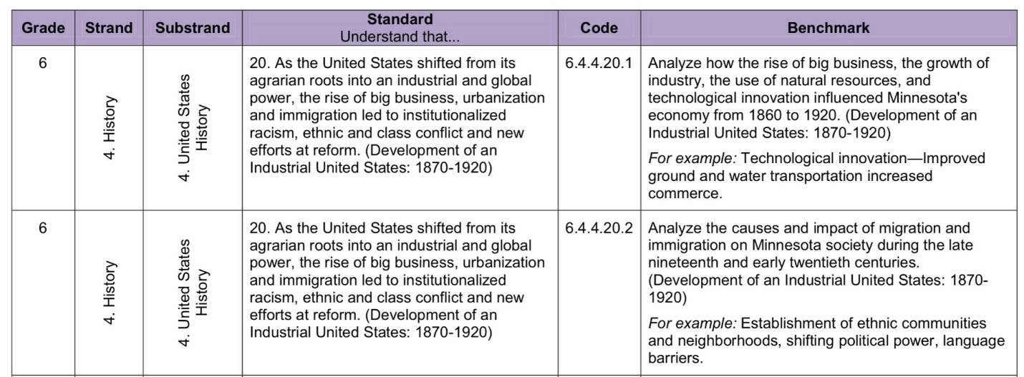

Subject: Geography, Social Studies, Art and Design, Other, History

Grade Levels: 6-8

Time Needed: 30 Minutes

Procedure:

Access the SMART Notebook game board at http://exchange.smarttech.com/details.html?id=6e979757-554e-48b3-9598-83d008b00924

*Note: you must have a free account with Smart Exchange in order to access this game. You can go to Smart Exchange and type “Who Built Our Capitol?” into the search box if you have trouble with this link.

Split students into two large groups, or into several smaller groups of 2-5 students. Each group takes a turn answering Jeopardy style questions. Groups select the category and point value they wish to attempt from the game board. Answers are found in the link under each question. Student responses should be in Jeopardy question format. Continue until all categories and point values have been exhausted. At this point, final scores can be tallied.

Assessment: Summary for all curriculum lessons
•Students will complete a video guide for the video, Who Built Our Capitol?
•Students will complete an Individual Worker Exercise using the website
•Students will complete a photo investigation summary
•Students may also write response for the Dangerous Work Conditions activity
•The nature of the Jeopardy game lends itself to subjective assessment. Participation may be used as a measure of success.
•Students will participate in other selected activities.

How to Differentiate Instruction:
1) Students could work with partners or in cooperative teams
2) Differentiate reading materials to accommodate individual needs of students.

